**Retrieve the Employee Details**

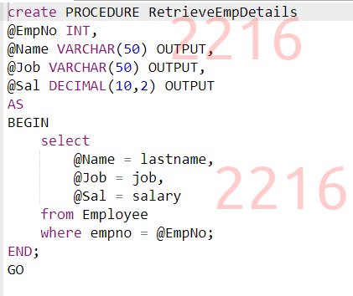

**Display Employees of a specific Department**

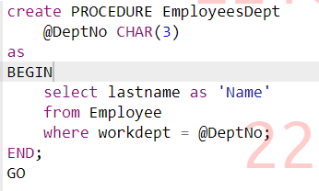

**Employee Count per Department**

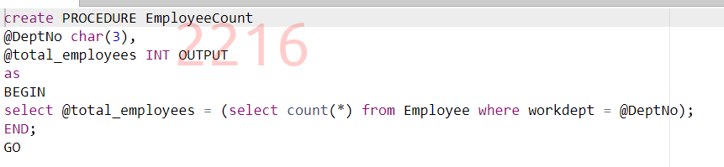

**Retrieve the Player Data**

**Report on Departments Salary**

**Count the number of Agents of a City**

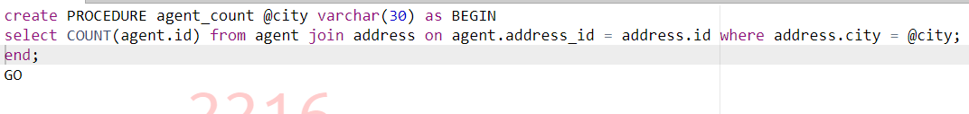

**Find Customer Policy**

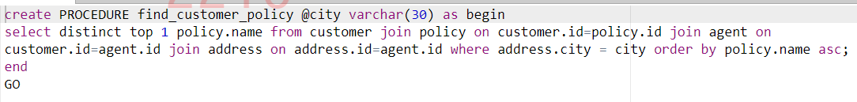

**Duration of Claim**

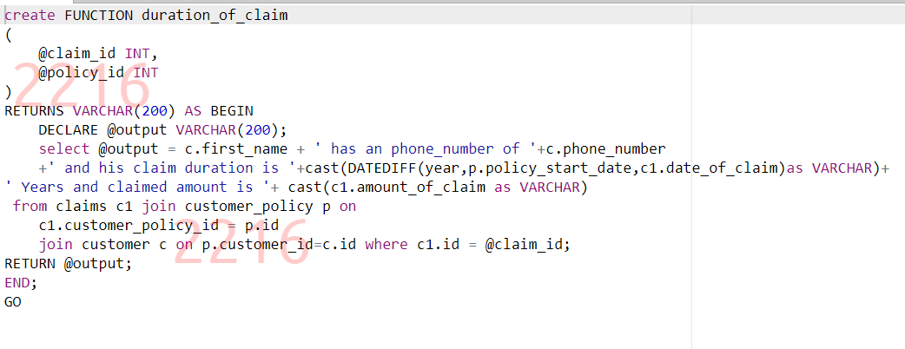

**Customer Details**

**Update Customer**

